
Agnel Charities

Fr. C. Rodrigues Institute of Technology, Vashi
Department of Electronics and Telecommunication Engg.
SUB: Image Processing & Machine Vision (ECC604/C3028)
AY 2023-24

Spatial Domain Filtering (CO-1)
Expt No : | 04
Aim: | To employ spatial domain filtering techniques for improving appearance of given images.
Required to know:  Expected Outcome: | Technique for spatial domain filtering, masks and their sizes  - To gain hands-on experience in implementing spatial domain image smoothing algorithms using Python programming language.  - To observe the effects of varying filter parameters, such as kernel size, custom weights and standard deviation, on the degree of smoothing.
Procedure: | Task 1: Procedure given below explain the steps for low pass filtering operation. Students are instructed to follow similar steps for high pass filtering  Image: dip_text.tif  - Import all the necessary modules, libraries in python as shown in following piece of code  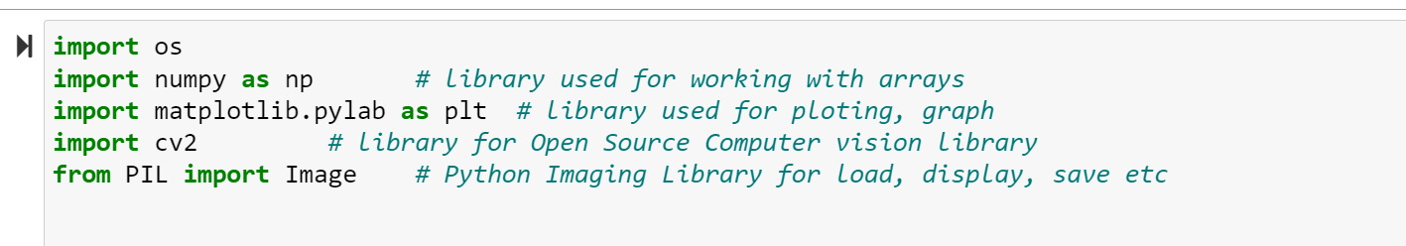  - Read the image, convert to grayscale and save the size(as you had done in your lab3).  - Create an filter kernel matrix with dimensions corresponding to the chosen kernel size.  - Populate the filter kernel matrix with equal weights (e.g., 1/N, where N is the total number of elements in the kernel) to implement an averaging filter. Following piece of code shows the implementation of 3 by 3 kernel. Implement for 5 by5, 7 by7. Print the kernel.  - 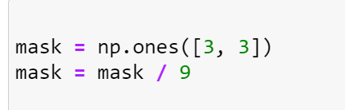  - Iterate over each pixel in the input image.  - For each pixel, perform the following steps:  - Place the center of the filter kernel over the current pixel.  - Compute the weighted sum of pixel values within the kernel neighborhood using element-wise multiplication with the filter kernel.  - Assign the resulting sum to the corresponding pixel location in the output image.  - Repeat the process for all pixels in the image. Study the following code to understand these steps. Comment on the values used in ‘for ‘ loop. Remember these are for [3 X 3 ] kernel or mask.  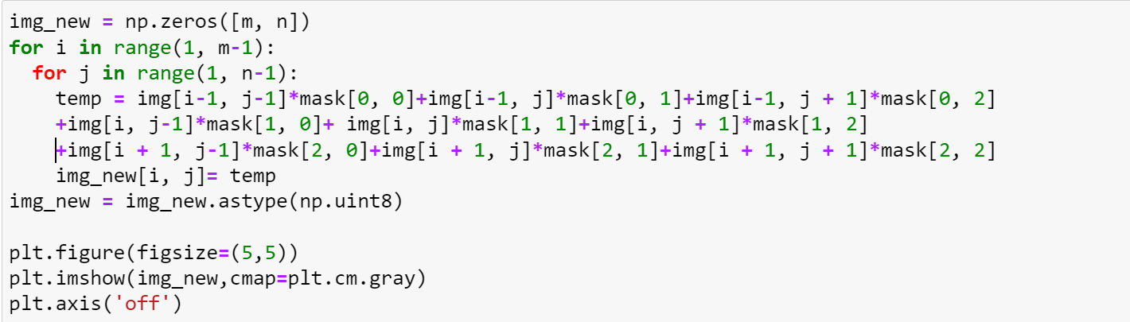  - Plot the original and smoothed images side by side for comparison.  - Try implementing other spatial domain filters by changing the kernel weights.  - Perform high pass filtering on the same image by modifying code.  Sample output  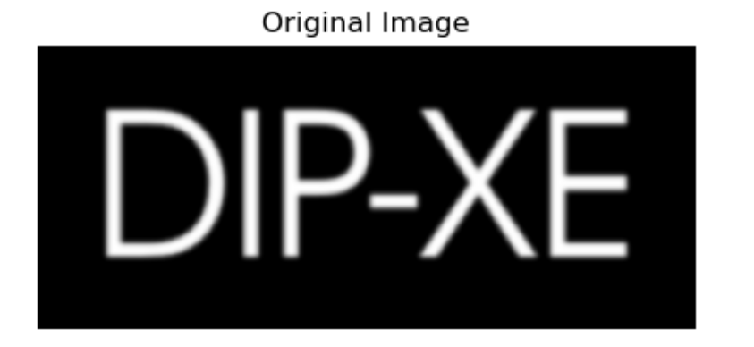  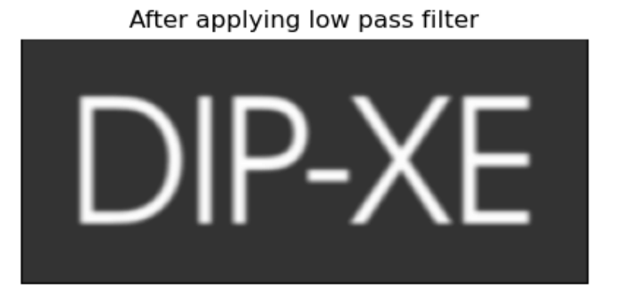
Conclusion:  Additional Questions: | Should address use of both the filters in image enhancement, specialty of each filter, and complexity of processing.  - Write code for replicating borders so that processing can happen from pixel (1,1).  - Write the additional steps to be followed for high boost filtering. (You can write the code in the lab and demonstrate it to the instructor).

